Title of the Full Paper
This template provides information for CINet authors regarding the preparation of their structured abstract. We request that authors use this template and the styles embedded in the document to facilitate the review process.
The title should capture the essence of your research and not exceed ten words.
Do not include author names, affiliations and contact information in the abstract.

Keywords: Include three to five keywords here, which are specific and reflect the essence of your research.

Length: Provide the length of the body (i.e. not counting the list of references) of the abstract. The length should be between 750 and 1,000 words.

Session track: Indicate the session track you feel your research is best placed in.

Theoretical and Empirical Background and Relevance
The background section of your abstract must reflect the theoretical and empirical considerations behind your (intended, ongoing, completed) research. Draw on literature that is relevant to studies of continuous innovation and adjacent fields. Include clear and explicit references to theory – this allows for a clear positioning of the contribution of the research. Address the question why the research is important from a practical perspective. Clarify the significance of your research, research idea or work-in-progress: is it new and large enough, is it interesting and important, for whom (researchers, practitioners)?

Research Objectives, Problem and/or Hypotheses
The research objectives, problem and/or hypotheses should be clearly stated. Be very explicit in saying what you aim to achieve with the research.

Research Design
This section must describe the methods you (intend to) use in the research, and provide information about your (intended) sample, constructs and variables, methods of data collection and validation, and analytical techniques.

Discussion and (Expected) Contribution
The abstract should discuss the (expected) results and, based on that, clearly point out the (expected) contribution of the research to continuous innovation theory and/or practice.

Page Limit
The abstract should be 750-1,000 words in length, the list of references not included. Abstracts that do not meet these limits will be sent back to the corresponding author.

Graphics and Tables
All graphics must be embedded within the text at the appropriate position.
Use the “CINet Figure Caption Body” style for figure captions. Word automatically generates the caption label and counter at the time of insertion.

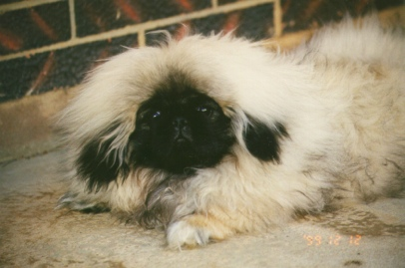
Figure 1. Style is “CINet Figure Caption Body”
Use the “CINet Table Caption Body” style for table captions. Word automatically generates the caption label and counter at the time of insertion.
Use the Table function of Word to generate tables. Do not insert them as objects.

1 | 2 | 3 | 4 | 5 | 6 | 9 | 10 | 11 | 12
13 | 14 | 15 | 16 | 17 | 18 | 21 | 22 | 23 | 24
25 | 26 | 27 | 28 | 29 | 30 | 33 | 34 | 35 | 36
Table 1. Caption style is “CINet Table Caption Body”

References
Include a complete list of references at the end of the abstract. Abstracts without such a list will not be accepted. Use the following styles to organize the list of references

Adam, J. (2000), A Book on the History of Innovation, Anyville: Nowhere Press.
Doe, J. (2004), An Example of a Chapter in an Edited Volume, in: Reviewer, A.B.C. (ed.), A Book on Continuous Innovation, Anywhere: Outback Press, pp. 19-37.
Johnson, A. and Petersen, Z. (1998), A conference paper included in conference proceedings, in: Host, Q. and Co-Host, Y. (eds.), Proceedings of the 21st International CINet Conference on Continuous Innovation: Past, Present and Future, Somewhere Else, The Netherlands, September.
Smith, A. (2003), A journal article on creative management, Creativity and Innovation Management, Vol. 37, No. 2, pp. 81-91.

